Embargoed until Monday 8th March 00:01
Onjali Q. Raúf announced as BookTrust Writer in Residence
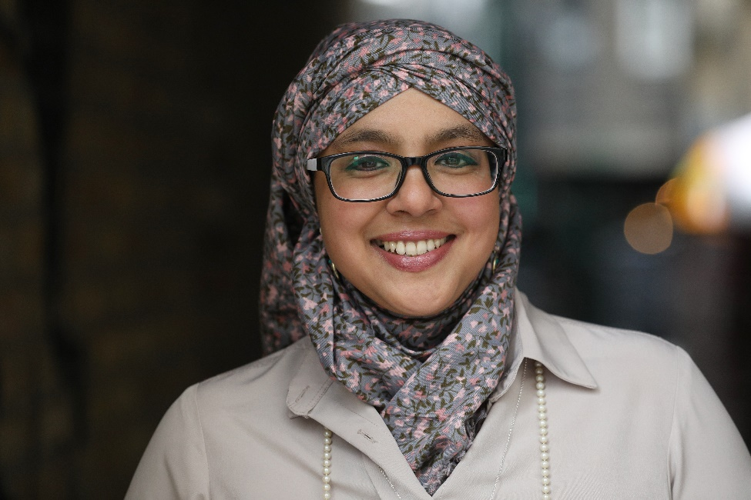
Photo credit: Rehan Jamil
Monday 8th March 2021 – Today, the award-winning author and activist, Onjali Raúf takes up the post as the new Writer in Residence for BookTrust, the UK’s largest children’s reading charity. The Boy at the Back of the Class author takes over from picture book writer Smriti Halls.

Raúf, a best-selling children’s author, writes thought-provoking books that tackle the issues of today. Her titles include The Boy at the Back of the Class, in which a young boy from Syria is befriended by his classmates in the UK; The Star Outside My Window, which features the theme of domestic violence; The Night Bus Hero, which contains themes of bullying and homelessness; and her 2020 World Book Day title follow up to The Boy at the Back of the Class, The Day We Met the Queen.

The BookTrust Writer/Illustrator in Residence project has been running since March 2009 and has featured several authors and illustrators including Cressida Cowell, Sita Brahmachari, Patrick Ness, Polly Dunbar, Bali Rai, Matt Haig, Laura Dockrill, Chris Riddell, Sarah McIntyre, Philip Ardagh, Taran Matharu, Nadia Shireen, Candy Gourlay, Phil Earle, Ed Vere and Smriti Halls. The residency encourages each writer or illustrator to explore topics that they are passionate about, with past residents exploring themes such as the power of stories, diversity in children’s literature and the importance of libraries.

Onjali is also the founder of the NGO Making Herstory, a women's rights organisation tackling the abuse and trafficking of women and girls in the UK and beyond. She is also the founder of O’s Refugee Aid Team, which provides support for refugee families surviving in Calais and Dunkirk. Rauf will be using her time as BookTrust’s Writer in Residence to highlight literary inspirations related to a different issue each month - from human rights and the environment, to poverty and racism. Onjali will introduce us to all the books that have inspired her, learn about the books which have inspired readers to take action, and share the experiences of real-life amazing people who are doing their bit locally to tackle the biggest global issues of our day.

Talking about her residency, Raúf said: “I have always wondered what being a ‘writer in residence’ actually means, and can hardly believe that I now get to find out thanks to the generous hearts at BookTrust - an organisation filled with so many cool bookworms, it makes being a bona fide book-anything cool too!

Receiving the gift of this residential key from the one and only Smriti Halls, I am deeply excited to be spending the next six months shining a light on those authors whose magical story-telling powers have made (and still make) me want to get up and act on an issue that matters to me deeply: issues that I hope will interest and matter deeply to you too.

And whilst I can’t wait to share the stories, both real and imaginary, that inspire me, I am also keen to expand my own horizons. Because what I really want to do, is learn from you too and hear about all the s/heroes in your neck of the woods working hard to make the world a kinder, better place to be in for all.

So come join me as of 8 March, this year’s International Women’s Day, and let’s get thinking, asking, and championing amazing books written by amazing people, together!”

Diana Gerald, CEO BookTrust said: “We're so excited to welcome Onjali as our newest Writer in Residence. It's been a hard year for children and families and we're proud to support Onjali on her mission to encourage young activists, showcase those who are making the world a better place and get children excited about books and reading.”
[Ends]
Press Contacts: Sinéad Gosai, Press Manager, BookTrust, sinead.gosai@booktrust.org.uk, +44 (0)20 7801 8849
Onjali Q. Raúf is the founder and CEO of two NGO’s: Making Herstory, an organisation mobilising people from all walks of life to tackle the abuse and trafficking of women and girls in the UK and beyond; and O’s Refugee Aid Team, which delivers emergency aid and funds to frontline refugee aid teams in northern France and Greece.

Her first children’s novel, The Boy at the Back of the Class, is a child's perspective on the refugee crisis and went on to win the Waterstones Children’s Book Prize and the Blue Peter Book Award in 2019. Her second children’s novel, The Star Outside My Window, tackled the impact of domestic abuse on children’s lives and was awarded the 2020 Diversity Book Award for children’s fiction. In 2020, a mini-sequel to The Boy at the Back of the Class, entitled The Day We Met The Queen was released to mark World Book Day, and was shortly followed by the publication of her latest novel, The Night Bus Hero - a story which deals with the impact of homelessness and bullying.
BookTrust is dedicated to getting children reading because we know that children who read are happier, healthier, more empathetic and more creative. Their early language development is supported and they also do better at school.
We are the UK’s largest children’s reading charity; each year we reach 3.9 million children across the UK with books, resources and support to help develop a love of reading, because we know that reading can transform lives.
We work with a variety of partners to get children excited about books, rhymes and stories, because if reading is fun, children will want to do it. Our books are delivered via health, library, schools and early years practitioners, and are supported with guidance, advice and resources to encourage the reading habit. booktrust.org.uk

