Embargo: 00:01 Tuesday 5th November 2019

Just one book can brighten a vulnerable child’s Christmas
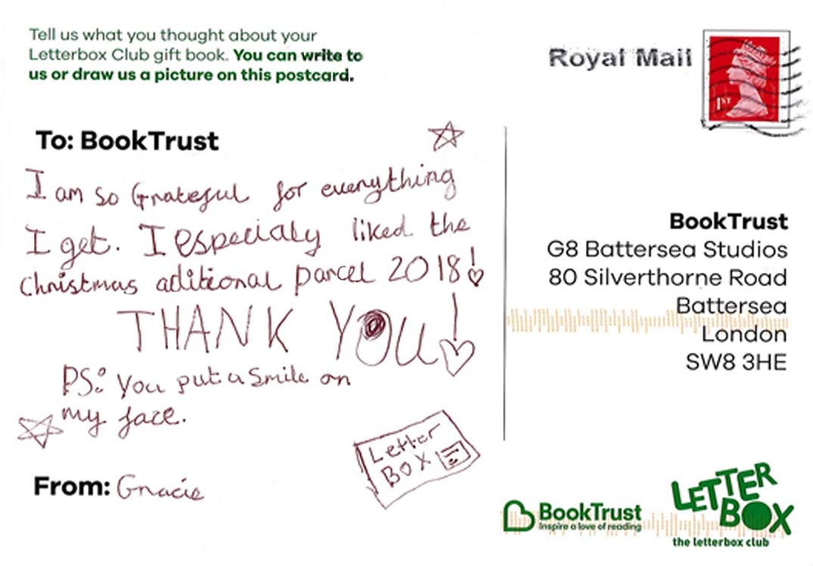
BookTrust appeals to public to donate £10 to send a book gift to a vulnerable child this December
BookTrust is appealing to the public to dig deep this Christmas and help send special book gifts to children who are vulnerable or in care.

The UK’s largest children’s reading charity needs to raise enough money to send over 12,000 children in the UK a special Christmas gift.

Christmas can be a hard time of year for these children, but a surprise book gift can bring them joy and show them that there’s someone’s out there thinking of them. Just £10 will send a vulnerable child a surprise Christmas present to unwrap and treasure this December.

BookTrust has carefully chosen six beautiful hardback books for children aged three-13 in the Letterbox Club, BookTrust’s programme for children who are vulnerable and looked after.

Each parcel contains one specially chosen hardback book, a letter from award winning author and current Waterstone’s Children’s Laureate Cressida Cowell, a poster and bookmark created by Neal Layton, and a postcard.

Cressida Cowell, best-selling children’s author and current Children’s Laureate said: “I am so happy and proud to be included in the Christmas gift parcel this year, and thrilled children are being sent a book in this parcel as a present! Books make the BEST presents, because they help you dream big, and make your own magic. I hope this Christmas parcel puts a smile on every child’s face and makes them feel special and important – as all children should.”

Children who are looked after are more likely to experience home or school moves, and these parcels, which are delivered directly to them wherever they’re living, provide a sense of continuity and stability, which is very important throughout the year but even more special at Christmas time.
Diana Gerald, CEO, BookTrust says: “This time of year can be extremely tough for vulnerable children and at BookTrust we want to make this time a little easier for them if we can. A £10 donation can send a book gift to one child, and go some way to brighten their Christmas and help them feel special.”

Money raised from the appeal will also support sending book gifts during 2020 and BookTrust’s work with vulnerable children throughout the year.

For more information or to donate to BookTrust’s Christmas appeal visit booktrust.org.uk/xmas

[Ends]
Press Contact: Jessica Rudd Jessica.rudd@booktrust.org.uk +44 (0)20 7801 8850
Notes to Editors

Included in this year’s book parcels:
- A special hardback book
- A letter from Waterstones Children’s Laureate Cressida Cowell
- A poster and bookmark created by Neal Layton and signed by Cressida Cowell and Neal Layton
- A feedback postcard

The books that have been selected:

- 3-5 years – Maisy’s Funfair by Lucy Cousins
- 5-7 years – The Paddington Treasury by Michael Bond
- 7-9 years (not reading independently) – Anthology of Very Intriguing Animals (DK)
- 7-9 years – Very Important Animals (DK)
- 9-11 years – Great Adventurers by Alastair Humphreys
- 11-13 years – Guinness World Records 2020
BookTrust sends Christmas packs to 6 age groups:
- Letterbox Purple (children aged 3-5)
- Letterbox Orange/Yellow (children aged 5-9)
- Letterbox Yellow (children aged 7-9, not yet reading independently)
- Letterbox Blue (children aged 7-9)
- Letterbox Red (children aged 9-11)
- Letterbox Green (children aged 11-13)

BookTrust runs Letterbox Club in partnership with the University of Leicester. 2018 marks 15 years of the Letterbox Club, which was started in 2003 by Professor Rose Griffiths.

About BookTrust
BookTrust is dedicated to getting children reading because we know that children who read are happier, healthier, more empathetic and more creative. Their early language development is supported and they also do better at school.
We are the UK’s largest children’s reading charity; each year we reach 3.9 million children across the UK with books, resources and support to help develop a love of reading, because we know that reading can transform lives.
We work with a variety of partners to get children excited about books, rhymes and stories, because if reading is fun, children will want to do it. Our books are delivered via health, library, schools and early years practitioners, and are supported with guidance, advice and resources to encourage the reading habit. booktrust.org.uk

