UNDER STRICT EMBARGO UNTIL THURSDAY 4 MARCH, 17:30

A Kind of Spark and A Day in the Life of a Poo, A Gnu and You are crowned winners of the 2021 Blue Peter Book Awards

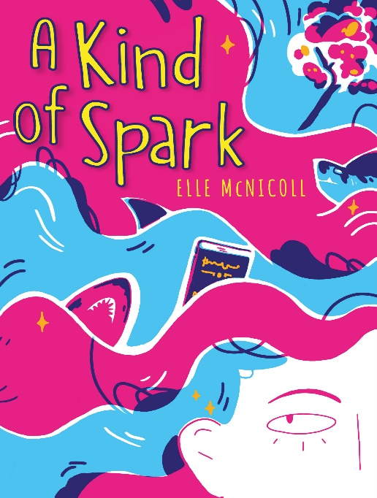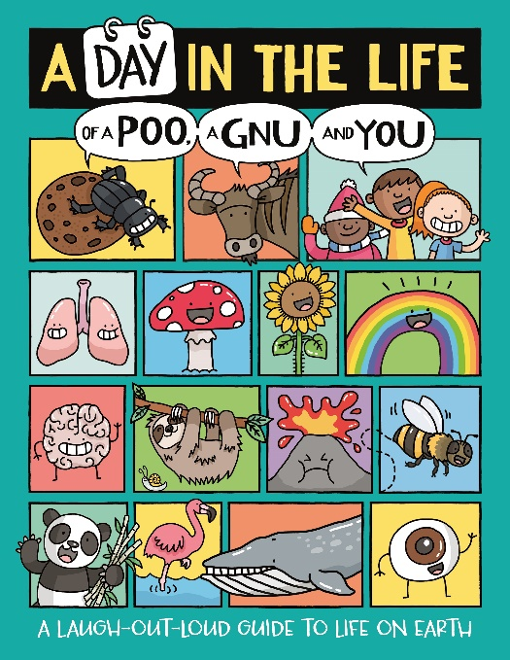
Spanning themes of friendship and celebrating difference to a laugh out loud cartoon book that explains unusual facts in a hilarious way, the winners of the annual Blue Peter Book Awards are sure to make readers laugh and cry in equal measure. Beating the stiff competition this year, the winner of Best Story is A Kind of Spark by Elle McNicoll and winner of the Best Books with Facts is A Day in the Life of a Poo, A Gnu and You by Mike Barfield and Jess Bradley.

A Kind of Spark is the brilliant debut novel from neurodivergent writer Elle McNicoll, offering an utterly convincing and honest narrative voice. Challenging the stereotypes that can be associated with autism, this is a powerful book with a gentle touch which teaches us that there are ‘many different ways to be autistic’. Readers will revel in joining Addie in her crusade for equality and truth, celebrating the fact that it is okay to be different.

Author, Elle McNicoll said: "As someone who grew up watching Blue Peter and discovering brilliant new books from the show, it is an extraordinary moment to be recognised. To be a part of their World Book Day celebrations is great, and to have been voted the winner by readers is life changing.”

A Day in the Life of a Poo, A Gnu and You gives readers the inside story of brains, pimples, farts, porcupines, Japanese knotweed, clouds, clocks, Mars rovers, snowflakes - and everything in between. Each element has its own page and is written in the form of a first-person diary, hilariously presented in strip cartoons. This book is fabulously informative as well as very funny and gives the reader the feeling of knowing everything that’s worth knowing.

Author, Mike Barfield said on receiving the award: “Winning any award is a huge honour but winning the Blue Peter Book Award is extra special. I adored the programme as a child, and again as a parent, watching it with my own (now grown-up) children. The child in me that still persists to this day does find it rather amusing that a book with ‘Poo’ in its title will now have to be mentioned several times on the show. Gnu-sized thanks to the programme, to BookTrust, my brilliant illustrator Jess Bradley, to publisher Buster Books and my lovely agent Anne Clark. All are a part of winning this prize.”

Illustrator, Jess Bradley said: “As someone who grew up watching Blue Peter, this is the MOST exciting award to win, so a massive thank you to all of the readers who voted for us. I had so much fun drawing everything from poos to gnus, and I’m really happy to know that so many children enjoyed reading about them!”

Managed by BookTrust, the UK’s largest children’s reading charity, the immensely popular Blue Peter Book Awards honour amazing authors, imaginative illustrators and the best books for children, published in the last 12 months. The winning titles were voted for by over 200 children from 12 schools across the UK.

Diana Gerald, CEO, BookTrust commented: “Every year without fail, the Blue Peter Book Awards showcase the exceptional talent in the world of children's books and this year is no different. These fantastic books will help children to be inspired, creative, confident and encourage different ways of thinking. As always with the judging, it was a very close call, but Elle, Mike and Jess triumphed. Congratulations to the very deserving winners.”

On Thursday 4th March, Elle Mike and Jess will all be guests in the special World Book Day edition of Blue Peter on CBBC and BBC iPlayer from 5pm.

Blue Peter Editor, Ellen Evans, says: The Blue Peter Book Awards give kids the opportunity to vote for their favourite books and it’s fantastic to hear them talk about reading for fun. The two winners are brilliant books. I hope Elle McNicoll’s A Kind of Spark will inspire kids to find their own voice, like Addie, and to stand up for what they believe in. Mike Barfield and Jess Bradley’s A Day in the Life of a Poo, a Gnu and You, is so visual and fun, that young readers will love discovering all kind of facts about the world they live in, from the secret diary of a slug, to how your heart beats, or why volcanoes explode.”

Blue Peter is live every Thursday at 5pm on CBBC and BBC iPlayer - https://www.bbc.co.uk/cbbc/shows/blue-peter

Keep up-to-date with the Awards at www.booktrust.org.uk/bluepeter and on Twitter by following @Booktrust and #BPBA
[Ends]

Press Contacts: Sinéad Gosai, Press Manager, BookTrust, sinead.gosai@booktrust.org.uk, +44 (0)20 7801 8849
Notes to Editors
Shortlisted books for Best Story
- A Kind of Spark by Elle McNicoll
- Anisha, Accidental Detective: School’s Cancelled by Serena Patel, illustrated by Emma McCann
- Life of Riley: Beginner's Luck by Simon James Green, illustrated by Alexei Bitskoff

Shortlisted books for Best Book with Facts
- A Day in the Life of a Poo, a Gnu and You by Mike Barfield, illustrated by Jess Bradley
- Inventors by Professor Robert Winston, illustrated by Jessamy Hake
- The Humans by Jonny Marx, illustrated by Charlie Davis

Schools taking part in the judging process:
Catton Grove Primary School
Brookland Junior School
Kelvin Grove Primary
Garstang Community Primary School
Sacred Heart Primary School
Hamilton College
Beechview School
Charter Primary School
Laira Green Primary School
St Joseph's R.C. Primary School
St. Bernadette's Catholic Primary School
Allerton Primary School

The 2021 judging panel consisted of:
Ellen Evans Editor, Blue Peter
Angela Young Producer, Blue Peter
Esther Jackson-Burton Assistant Script Editor at BBC Children’s
Emily Drabble Head of Children's Books and Prizes at BookTrust
Caroline Hill-Trevor Head of Book Purchasing at BookTrust
Scott Evans Primary school teacher and reading lead in South Wales
Simon Hudd Primary school teacher and reading lead in London
Soraya Berry Secondary School Learning Resource Manager in London
Jasmine Richards Founder of Storymix

Blue Peter is the longest running children’s magazine programme in the world. As well as the Book Awards, the show’s family of presenters, live studio home, amazing competitions, incredible challenges, live music, interviews with celebrities, access behind the scenes, pets, makes and bakes, free games online and most importantly its commitment to the audience are all long standing elements of this iconic show. www.bbc.co.uk/bluepeter

About BookTrust
BookTrust is dedicated to getting children reading because we know that children who read are happier, healthier, more empathetic and more creative. Their early language development is supported and they also do better at school.
We are the UK’s largest children’s reading charity; each year we reach 3.9 million children across the UK with books, resources and support to help develop a love of reading, because we know that reading can transform lives.
We work with a variety of partners to get children excited about books, rhymes and stories, because if reading is fun, children will want to do it. Our books are delivered via health, library, schools and early years practitioners, and are supported with guidance, advice and resources to encourage the reading habit. booktrust.org.uk

Elle McNicoll is a children’s author from Scotland, now living in East London. She is a neurodivergent writer and is passionate about disability rights and #OwnVoices representation. Her debut novel A Kind of Spark was published to critical acclaim in June 2020. Her second novel, Show Us Who You Are – a near-future, sci-fi story with two neurodivergent characters you'll root for and a moving friendship at its heart – is published by Knights Of on 4th March.

Mike Barfield is a writer, poet, performer, songwriter, ukulele player and cartoonist. He has written extensively for TV and radio with credits as diverse as The Dennis the Menace and Gnasher Show and Who Wants To Be A Millionaire? His cartoon drawings have been displayed in The Cartoon Museum, V&A Museum, Museum of London and beyond. When Mike isn’t busy writing and drawing, he performs shows and humour-filled workshops at schools, libraries and festivals across the country. His website can be found at www.mikebarfield.co.uk

Jess Bradley is an illustrator and comic artist from Torquay. As well as writing and drawing for The Phoenix, she also writes for The Beano and illustrates a variety of children’s books. She has created puzzle and activity and comic books for various publishers, including contributing to Usborne’s bestselling Write and Draw Your Own Comics. Her work for Buster Books includes the Bright Sparks series, I Heart Cute Colouring and the laugh-out-loud A Day in the Life of a Poo, a Gnu and You.

